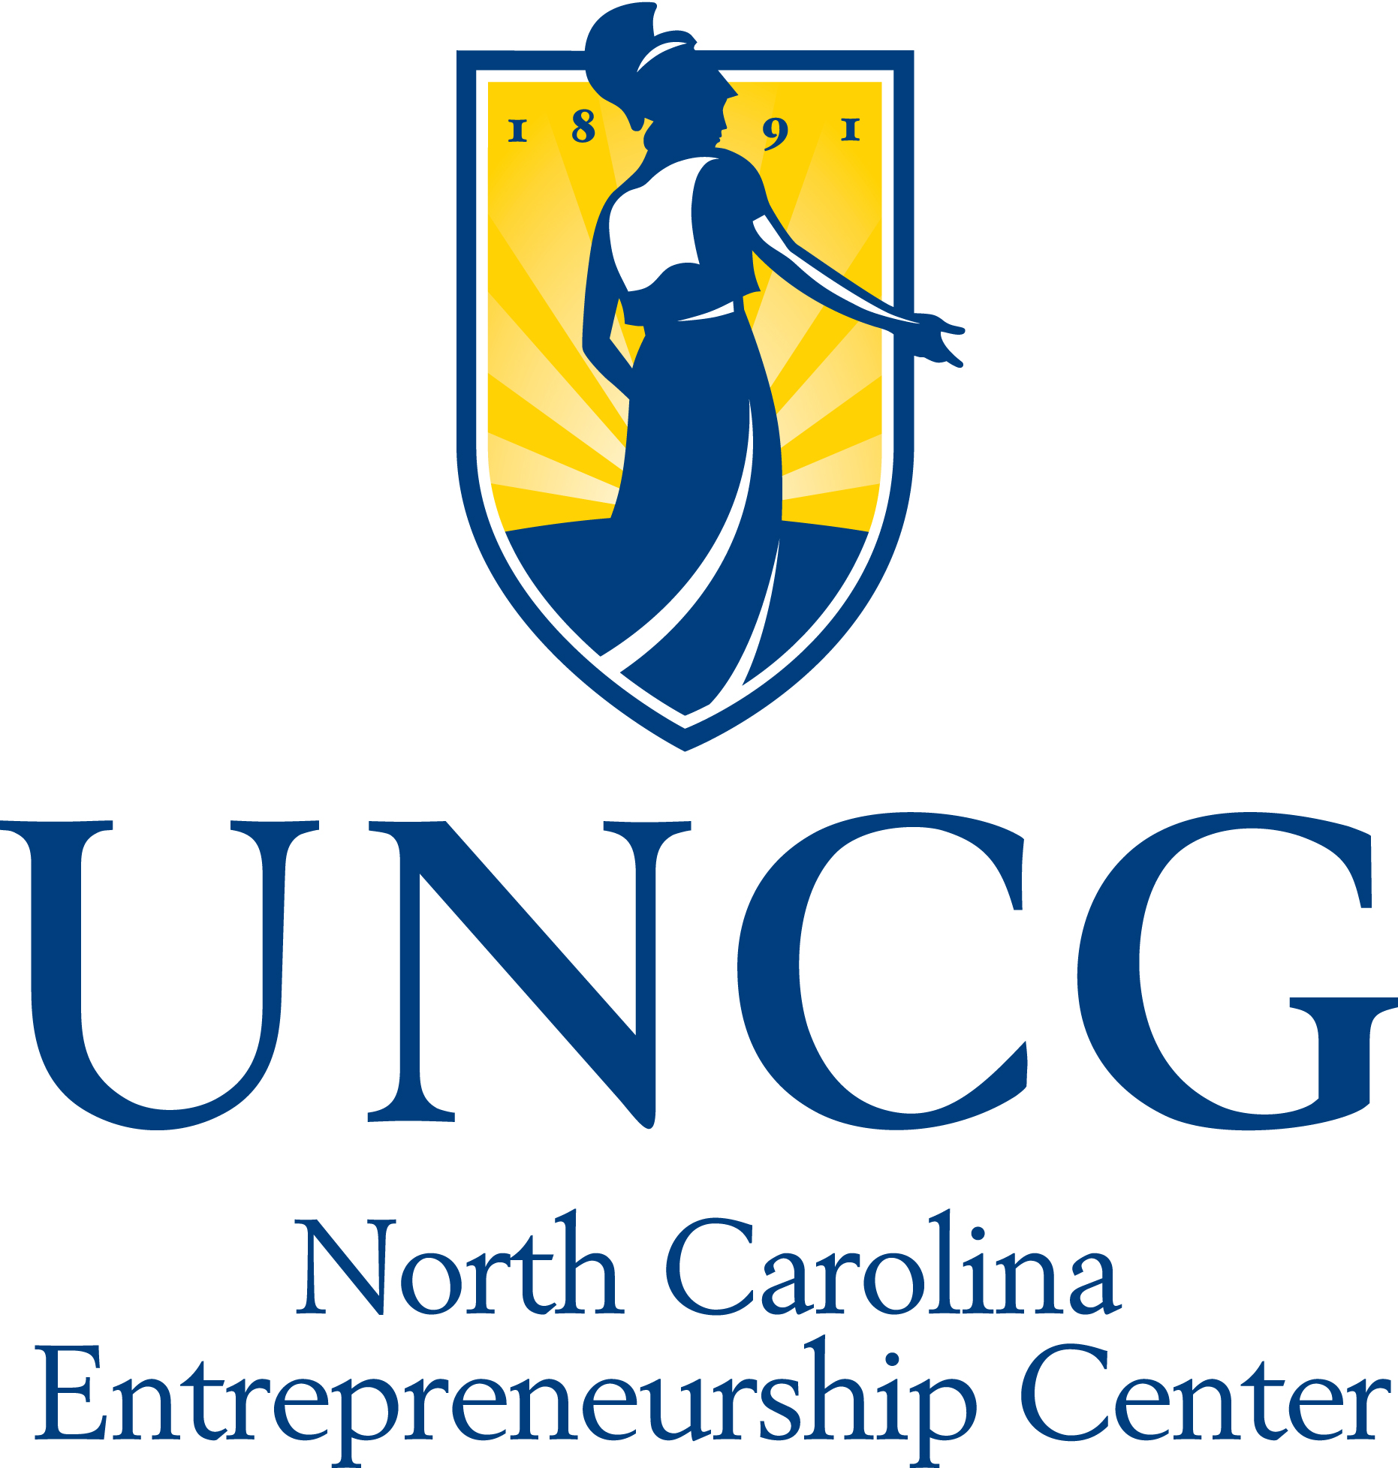


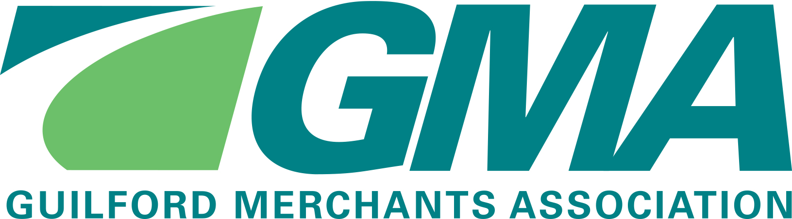
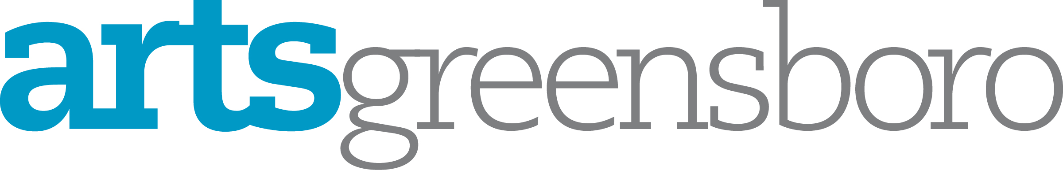

2016 Arts In Business Award
Nomination Form

Eligibility:
- Nominees must be a Greensboro-based small business with 100 or fewer employees in the greater Greensboro area. Foundations, individual philanthropists, government agencies, and arts organizations are not eligible to compete. Self-nominations are accepted.
- Recipients of the Arts in Business Award must have a significant impact on the arts through a variety of activities or through a single project of significant magnitude.

Past recipients: 2015 – Tate Street Coffee, for serving as a collaborative meeting space for artists and being a generous supporter of community arts events and projects; 2014 – Just Be, for its support of over 60 local artists and local arts events; 2013 – PhotoBiz, for its contribution to the arts through its relationships with local arts organizations such as its partnership with the Center for Visual Artists to create a mural on Spring Street in downtown Greensboro.

Award decisions will be made based on the information contained in the nomination form. The Arts in Business Award recipient will be recognized at the Greensboro Chamber of Commerce’s Small Business Awards Luncheon on May 5, 2016. Nominations must be received by ArtsGreensboro by 5 pm on Tuesday, April 12, 2016.

Nominee:

President/Owner: # of Employees:

Mailing Address:

Daytime phone: Email:

Nominated by:

Organization & Title (if applicable):

Mailing Address:

Daytime Phone: Email

See page 2 for additional information to be provided

- Give a brief statement in support of nomination, answering the following questions :
- How does the nominee incorporate the arts in the workplace?
________________________________________________________________________________________________________________________________
________________________________________________________________________________________________________________________________
________________________________________________________________________________________________________________________________
________________________________________________________________________________________________________________________________
________________________________________________________________________________________________________________________________

- How does the nominee enhance the economic vitality and/or quality of life of the greater Greensboro community?
________________________________________________________________________________________________________________________________
________________________________________________________________________________________________________________________________
________________________________________________________________________________________________________________________________
________________________________________________________________________________________________________________________________
________________________________________________________________________________________________________________________________

Examples of activities that support a nomination:
- Business that promotes the arts in one or more ways (e.g., a gallery that promotes art, a performance venue, or business that incorporates an arts-education component)
- Business that provides arts volunteers (employee participation, sponsorship or other financial support of the arts)
- Business that incorporates the arts into its company culture
- Business that makes an impact on individual employees, customers, clients and/or the community through its arts support or engagement

- Submit 3-5 letters of support for the nominee and/or 3-5 pictures. Each letter of support should not exceed one page in length.

- Email completed nomination form with letters of support to: ksmith@artsgreensboro.org -- OR --Mail nomination to Kaitlin Smith, ArtsGreensboro, PO Box 877, Greensboro, NC 27402.

